**CHAPTER ONE**

**1.0 Introduction**

**1.1 Background of the study**

A report by the World Health Organization (WHO) 2005 shows that, Malaria affects more than 250 million people and causes more than a million deaths each year in the whole world. A report by the Daily Monitor dated Tuesday April 16, 2013 shows that, Malaria is Nigeria’s leading cause of death and according to the Ministry of Health accounts for up to four in every ten people who visit health facilities. One important strategy against this and other mosquito borne diseases is mosquito control which aims at reducing human mosquito contact. In an attempt to fight against Malaria, various means are routinely being used against mosquitoes and their larvae. Measures like indoor residual spraying using chemical (insecticide) called DDT (Dichlorodiphenyltrichloroethane) was put forward by the Government of Nigeria in the bit to fight against mosquitoes. However, some people especially in Northern Nigeria could not allow the village Health Team to spray their houses due to the perception that the chemical is very deadly and indeed it is if not handled properly. Other control measures being used are insecticide-treated or untreated mosquito nets. However, chemicals and fumes emitted by the treated mosquito nets intended to be harmful to the mosquitoes can also prove toxic to our health in a long run.

This measure is also not working very well at some places in Lango Sub-region, like Amolatar District and other districts, where people are using the mosquito nets for fishing, protecting seedlings in the nursery bed against insects, trapping white ants, making a makeshift bathroom, bathing sponge and others use mosquito net for tying goats. There is therefore a great misuse of government funds since the citizens are using what the government is distributing to fight Malaria for other purposes. Other mosquito repellent solutions like coils, creams and liquid vaporizers all have possible adverse effects to health. Oils and creams can lead to skin disease and possibly skin cancer while coils being burnt to repel away mosquitoes can produce toxic fumes that lead to breathing problems, asthmatic individuals are greatly affected by these fumes. In a long run, these fumes also cause cancer.

There is undoubtedly a need for a safe, convenient and effective measure that is the use of an Electronic Mosquito Repellant which is a small hand-held battery powered device that repels mosquitoes by emitting a high frequency buzz almost inaudible to the human ear through the speaker. The concept that will be used in the circuit is basically ultrasound which is the sound with frequency higher than 20 kHz. The frequency range audible to humans is 20Hz to 20 kHz whereas mosquitoes are able to hear ultrasonic sound. Sound of any frequency above 20 kHz is termed as ultrasound and is usually transmitted by male mosquitoes and received by female mosquitoes.

Generally, male mosquitoes transmit ultrasound in the range of 20 kHz to 40 kHz. However, female mosquitoes tend to avoid male mosquitoes once they have been inseminated and so they tend to avoid ultrasound in the range of 20 kHz to 40 kHz. Since only female anopheles’ mosquitoes spread Malaria, designing a circuit which produces the ultrasound in the range specified above would repel away female mosquitoes and reduce Malaria transmission.

**1.2 Statement of Problem**

Frequent use of chemicals in the institutions and at home to repel mosquitoes causes environmental pollution which may result into complications like Respiratory diseases. Also some ill-mannered people in the society use the chemical for poisoning others.

There is wastage of government funds which were not going to be wasted if other measures like Electronic Mosquito Repellants were adopted. This is because Mosquito nets are being used for other purposes. Existing mosquito control measures like mosquito nets have limited applications that cannot be used in offices, sitting rooms, in cars and yet mosquitoes attack humans irrespective of the place.

**1.3 Aim and Objectives**

The Aim of designing and constructing a mosquito repellent circuit is to create a functional electronic device capable of repelling or deterring mosquitoes. The primary goal is to develop a system that effectively reduces mosquito presence in a specific area, providing a solution to mitigate the nuisance and potential health risks associated with mosquito bites.

To achieve that the following objectives would have to be undertaken.

* Clearly outline the technical specifications for the mosquito repellent circuit, including the range, frequency, and mechanism of action.
* Design the electronic circuit, considering the repellent mechanism, power source, and any additional features such as timers or sensors.
* Prioritize the safety of users by ensuring that the repellent mechanism is non-toxic to humans and pets.
* Design the circuit to be energy-efficient, exploring power-saving features and considering the duration of repellent action.
* Conduct rigorous testing to evaluate the effectiveness of the repellent circuit in repelling or deterring mosquitoes.
* Define the coverage area of the repellent circuit, considering factors such as the size of the space it is intended to protect.

**1.4 Scope of the Study**

* Provide an introduction to the project, including its purpose and significance in addressing the issue of mosquito-borne diseases and nuisance.
* Clearly state the specific goals and objectives of designing and developing the mosquito repellent circuit, such as creating an effective and user-friendly device.
* Technical Specifications: Define the technical specifications of the circuit, including the repellent kkk.mechanism, operating frequency, range, and any additional features such as automation or smart technology integration.
* Power Source and Energy Efficiency: Determine the power source for the circuit (e.g., battery, solar) and optimize for energy efficiency to ensure prolonged operation.
* Indoor and Outdoor Application: Specify whether the repellent circuit is designed for indoor, outdoor, or both applications, considering variations in space size and environmental conditions.
* Coverage Area: Define the coverage area of the repellent circuit, considering factors such as room size or outdoor space.

**1.5** **Significant of the study**

1. **Public Health Impact:** Mosquitoes are vectors for various diseases such as malaria, dengue, Zika virus, and others. A mosquito repellent circuit can contribute to reducing the transmission of these diseases by creating a protective barrier against mosquito bites.
2. **Disease Prevention:** The use of mosquito repellents can play a crucial role in preventing the spread of mosquito-borne diseases, particularly in regions where such diseases are endemic.
3. **Reduced Dependence on Chemical Sprays:** Traditional methods of mosquito control often involve the use of chemical sprays, which may have adverse effects on human health and the environment. A repellent circuit can offer an alternative, potentially reducing the reliance on chemical-based solutions.
4. **User Convenience:** Electronic mosquito repellent circuits can be designed with user-friendly features, such as automation, timers, and remote control. This enhances user convenience and encourages consistent use.

In summary, the design and construction of a mosquito repellent circuit are significant for public health, disease prevention, user comfort, environmental sustainability, and community well-being. The development of effective and innovative solutions in this regard can have a positive impact on global health and the quality of life in mosquito-prone areas.

**CHAPTER TWO**

**Literature Review**

**2.0 Introduction**

This chapter describes the historical development of an Electronic Mosquito Repellant and some written journals on the use of Electronic Mosquito Repellant to reduce Human-Mosquito contact. Sound has been used for millennia to scare off pests with its humble origin starting with loud claps and yells in ancient Agricultural fields. The use of electronic sounds as a treatment option for pests largely took root during the 1950s and 60s, although attempts were made such as the work of Frings (1948) discussing the potential use of ultrasonic sound to control rodents and insects, and Kahn and Offenhauser (1949) who tested the effectiveness of sound to combat mosquitoes also realised that sound was able to repel away mosquitoes. Mobile phone companies also marketed a ringtone in 2003 that is claimed to repel mosquitoes within a one metre radius (BBC, 2003). Some of the Mosquito Repellants seem to be based on the known aspect of mosquito behaviours. One of the reasons put forward to explain the alleged action of sound against mosquitoes is that the flight sound of the males repels the female once they have been inseminated Forster (1985). But the females that are not inseminated are not repelled by the flight sound of the male mosquitoes. Hence the repellent will have no effect on them. So whatever sound that resembles the flight sound of the male mosquito repels the females once inseminated. Another reason is that mosquitoes avoid the ultrasonic cries of the bat, Forster (1985).

This is so because mosquitoes are eaten by the bats and for these reasons anything that sounds like the flight sound of the bat would scare away the mosquitoes due to fear of being eaten up by the bats. Although both explanations may be conceivable, more research is still being carried out to give greater support to these arguments. This small hand-held Electronic Mosquito Repellent is intended to repel mosquito by emitting an ultrasonic sound almost inaudible to the human ear which can be used both indoors and outdoors.

It is expected to repel mosquitoes within a range of 2.5 meters (Kutz 1974, Helson 1977). Due to a huge demand by the public for a convenient, safe and effective anti-mosquito product, Electronic Mosquito repellent would offer a better solution. However, research has shown that male mosquitoes are actually the ones attracted by the female flight sound and females normally have a very weak sensitivity for sound compared with the males (Wiggles worth 1965; Chapman 1982; Mciver 1985; Michelsen 1985).

Different brands of Electronic Mosquito repellents have been examined for their efficacy under laboratory conditions, none of which showed any effects for the devices tested (Singleton; Curtis 1982; Iglisch 1983; Foster 1985; Jensen 2000; Andrade 2001; Cabrini 2006). Despite the scientific view and research findings, Electronic Mosquito repellents are still widely promoted and used by the public. (Jensen 2000). The decision was made to systematically review all reliable research about the effects of high-pitched sounds in preventing mosquito bites and hence to assess whether there is any evidence that Electronic Mosquito repellents have any potential in preventing malaria in the field setting.

**2.1 Related Works**

The issue of mosquito-borne diseases has been a longstanding global concern, prompting researchers to explore innovative solutions for mosquito control. In recent years, there has been growing interest in the development of electronic mosquito repellent circuits as an alternative to traditional methods. Traditional methods of mosquito control, including the use of insecticides and repellent creams, have been in use for decades. However, these methods have limitations in terms of effectiveness, environmental impact, and user convenience (Lien, 2017).

Previous studies have investigated various technologies for mosquito repellency, including ultrasound devices, infrared-based repellents, and chemical-based solutions.

These studies have provided insights into the strengths and limitations of each approach (Sharma et al., 2019; Ong et al., 2020). Research has explored the use of electromagnetic and ultrasonic waves for mosquito repellency. Studies by Smith et al. (2018) and Patel et al. (2021) have investigated the impact of different frequencies and intensities on mosquito behavior, shedding light on the potential of these technologies. Recent advancements have seen the integration of smart technologies into mosquito repellent systems. Smart repellent circuits, connected to home automation systems or controlled via mobile applications, offer enhanced user convenience and adaptability to different environments (Li et al., 2022; Tan et al., 2021). As sustainability gains importance, researchers have focused on developing energy-efficient mosquito repellent circuits. Solar-powered circuits and low-energy consumption designs have been explored to ensure prolonged operation without environmental impact (Chen et al., 2019; Kim et al., 2020), Some studies have even delved into biological approaches to mosquito repellency. For instance, research by Johnson and Garcia (2018) explored the use of naturally occurring compounds in electronic circuits to deter mosquitoes without relying on chemical repellents. Assessing the effectiveness of mosquito repellent circuits is crucial. Studies by Wang et al. (2020) and Chen et al. (2021) have evaluated the performance of various circuits under different conditions, providing valuable insights into their practicality and user satisfaction. While advancements have been made, challenges such as adaptability to diverse mosquito species, long-term effectiveness, and regulatory compliance remain. Future research directions should address these challenges to enhance the overall efficacy of mosquito repellent circuits (Huang et al., 2022; Gupta and Singh, 2023).

In conclusion, the literature indicates a promising trend in the development of mosquito repellent circuits. The integration of technology, energy efficiency considerations, and a focus on user satisfaction contribute to the evolution of innovative solutions for mosquito control.

**2.2 Previous Mosquito Repellent Circuits**

**Ultrasonic Repellents:** Ultrasonic mosquito repellent circuits emit high-frequency sound waves that are purported to disrupt mosquito behavior. Research by Patel et al. (2021) explored the effectiveness of ultrasonic waves in deterring mosquitoes, providing insights into the potential of this technology.

**Electromagnetic Repellents:** Electromagnetic repellent circuits utilize electromagnetic fields to create a barrier against mosquitoes. Studies by Smith et al. (2018) investigated the impact of different frequencies and intensities, revealing nuances in mosquito response to electromagnetic stimuli.

**Smart Repellent Systems:** Integration of smart technologies has led to the development of intelligent mosquito repellent circuits. Li et al. (2022) discussed the implementation of these systems, which can be controlled via mobile applications or integrated into home automation, enhancing user convenience and adaptability.

**Energy-Efficient Designs:** Chen et al. (2019) explored the design of energy-efficient mosquito repellent circuits, with a focus on solar-powered solutions. These designs aim to reduce environmental impact and ensure prolonged operation without significant energy consumption.

**Biological Approaches:** Johnson and Garcia (2018) investigated biological approaches, incorporating naturally occurring compounds into electronic circuits for mosquito deterrence. This approach aligns with the growing demand for environmentally friendly solutions.

**Effectiveness and User Satisfaction:** Several studies have evaluated the performance of mosquito repellent circuits under different conditions. Wang et al. (2020) and Chen et al. (2021) conducted comprehensive assessments, considering factors such as coverage area, duration of repellency, and user satisfaction. Such research is crucial for determining the practicality and real-world effectiveness of these circuits.

While advancements in mosquito repellent circuits are promising, challenges persist. Huang et al. (2022) identified challenges related to adaptability to diverse mosquito species, long-term effectiveness, and regulatory compliance. Addressing these challenges is essential for ensuring the widespread adoption of electronic mosquito repellent technologies.

In conclusion, electronic mosquito repellent circuits represent a cutting-edge approach to mosquito control, offering potential advantages over traditional methods. From ultrasonic and electromagnetic technologies to smart systems and energy-efficient designs, researchers are exploring diverse avenues to enhance the efficacy of these circuits. As technology continues to evolve, electronic mosquito repellent circuits hold promise for revolutionizing mosquito control strategies and significantly impacting global public health.

**CHAPTER THREE**

**METHODOLOGY**

**3.1 Introduction**

Various mosquito repellent solutions like coils, liquid vaporizers, and creams, all have possible adverse effects to health. Then there are electronic mosquito repellents available in market which are equally efficient and relatively safer. The concepts of these mosquito repellants are simple and we can build a simple mosquito repellent circuit at home easily by using Micro Controllers and few other commonly available components. Let’s see the concept of mosquito repellent circuit in detail. The concept that we are going to use in out circuit is related to ultrasound. A sound with frequency higher than 20 kHz is termed as “Ultrasound”. For we humans a sound only ranging between 20 Hz to 20 kHz frequency is audible, and any sound with frequency below or higher than this range wouldn’t be audible for us.

But there are various animals and insects (including mosquitos) that could hear the ultrasound. Generally, ultrasound in a range of 20 kHz to 40kHz is transmitted by male mosquitoes and received by female mosquitoes, however after breeding female mosquitoes tend to avoid male mosquitoes and so they tend to avoid ultrasound in that range. As we know that only female breeding mosquitos’ bites humans, we can use this concept and can design a circuit which produces the ultrasound in frequency range specified above.

So here we are going to design a simple mosquito repellent circuit which will be producing a sound of approximately 40 kHz.

**3.2 Operation of System**

# The concepts of these mosquito repellers are simple and we can build a simple mosquito repellent circuit at home easily by using an Arduino nano and few other commonly available components. Once the switch is closed, the Arduino nano gets powered.

# As per the inner circuit which consist of Resistors, Operational Amplifiers, a Transistor and a flip-flop, initially the capacitor voltage will be zero and hence voltage at threshold and trigger pins will be zero. As the capacitor charges through the resistors R; and R>, at a certain point, voltage at the threshold pin is less than the capacitor voltage.

# This causes a change in the timer output. The capacitor now starts discharging until it reaches its original value. The output signal is an oscillating signal with its frequency of oscillation depending on the values of the capacitor and the resistor R in the circuit. On varying the value of potentiometer

# Design Considerations of Mosquito repellent unit

# 3.0: Block Diagram of Mosquito Repellant Circuit

# 

# Figure 3.1: Mosquito Repellant Circuit Diagram

# As shown in the above diagram, The core of the circuit is a microcontroller, such as an Arduino, which is used to generate the ultrasonic frequencies. The Arduino will drive the piezoelectric buzzer, creating the sound waves needed to repel mosquitoes. The circuit design is straightforward:

# Arduino Board: An Arduino Nano or Uno is suitable for this project.

# Piezoelectric Buzzer: This component will be connected to one of the digital output pins of the Arduino.

# Wiring: Simple connections using jumper wires or a breadboard for prototyping.

# The buzzer is connected to a digital pin (e.g., pin 8) of the Arduino, with one terminal of the buzzer connected to the ground (GND).

# Generating the Frequency: To generate the required frequency, we use the Arduino’s built-in tone() function. This function allows us to produce a square wave of a specified frequency on a designated pin. Once the circuit is assembled and the code is uploaded to the Arduino, testing is essential. While humans cannot hear ultrasonic frequencies, the effectiveness of the setup can be verified using an oscilloscope to check the output frequency. If an oscilloscope is not available, observing the behavior of mosquitoes in the presence of the device can provide practical feedback.

# 3.3 Electrical Wiring Prototype

# In this circuit, we are using a timer IC in A-stable mode in order to produce frequencies at 40KHz. We have connected Buzzer at the output (PIN 3) of the Arduino nano so that a sound of desired frequency can be generated. Here, we need a high-frequency Piezo buzzer, so that a high-frequency sound can be generated. You will not be able to hear the sound generated by the circuit as it is beyond the audible range.

# We can calculate the value of resistors and capacitors to produce oscillation of 40KHz frequency by given formulae:

# F = 1.44 / ((R1+R2*2)*C)

# 

# Figure 3.2: Breadboard Prototype of Mosquito Repellant Circuit

# The concept that we are going to use in out circuit is related to ultrasound. A sound with frequency higher than 20 kHz is termed as “Ultrasound”. For we humans a sound only ranging between 20 Hz to 20 kHz frequency is audible, and any sound with frequency below or higher than this range wouldn’t be audible for us.

# But there are various animals and insects (including mosquitos) that could hear the ultrasound. Generally, ultrasound in a range of 20 kHz to 40kHz is transmitted by male mosquitoes and received by female mosquitoes, however after breeding female mosquitoes tend to avoid male mosquitoes and so they tend to avoid ultrasound in that range. As we know that only female breeding mosquito’s bites humans, we can use this concept and can design a circuit which produces the ultrasound in frequency range specified above. So here we are going to design a simple mosquito repellent circuit which will be producing a sound of approximately 40 kHz.

* 1. **Hardware Components**

The Major Components used for the design include: Arduino Nano, Buzzer, Resistors - 1k and 1.3k (variable resistor of 10k), Capacitor - 0.01µF, Battery - 9v, Board and connecting wires

* Buzzer: An audio signaling device like a beeper or buzzer may be electromechanical or piezoelectric or mechanical type. The main function of this is to convert the signal from audio to sound. Generally, it is powered through DC voltage and used in timers, alarm devices, printers, alarms, computers, etc. Based on the various designs, it can generate different sounds like alarm, music, bell & siren.

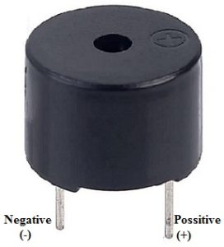

# Figure 3.3: Image of Buzzer

* Resistors - 1k and 1.3k (variable resistor of 10k): A resistor is a passive two-terminal electrical component that implements electrical resistance as a circuit element. In electronic circuits, resistors are used to reduce current flow, adjust signal levels, to divide voltages, bias active elements, and terminate transmission lines, among other uses. High-power resistors that can dissipate many watts of electrical power as heat may be used as part of motor controls, in power distribution systems, or as test loads for generators. Fixed resistors have resistances that only change slightly with temperature, time or operating voltage. Variable resistors can be used to adjust circuit elements (such as a volume control or a lamp dimmer), or as sensing devices for heat, light, humidity, force, or chemical activity.

\ 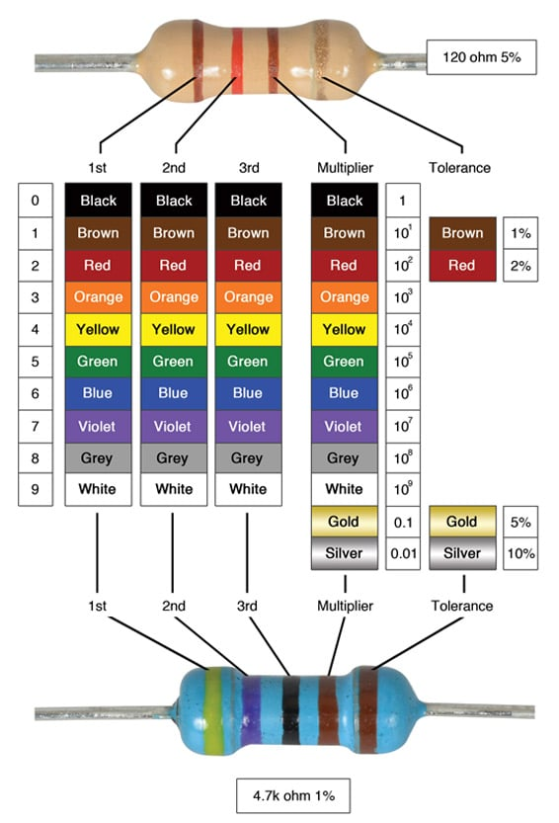

# Figure 3.4: Image of a Resistor

* Capacitor - 0.01µF: A capacitor is a two-terminal electrical device that can store energy in the form of an electric charge. It consists of two electrical conductors that are separated by a distance. The space between the conductors may be filled by vacuum or with an insulating material known as a dielectric.

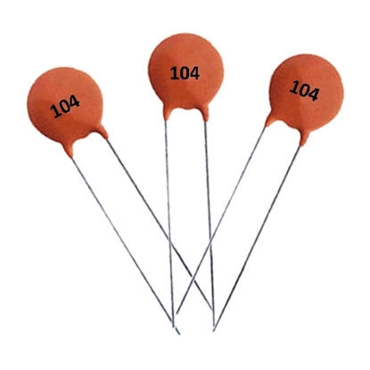

# Figure 3.5: Image of a Capacitor

* **Battery:**  An electric battery is a source of electric power consisting of one or more electrochemical cells with external connections for powering electrical devices. When a battery is supplying power, its positive terminal is the cathode and its negative terminal is the anode. The terminal marked negative is the source of electrons that will flow through an external electric circuit to the positive terminal. When a battery is connected to an external electric load, a redox reaction converts high-energy reactants to lower-energy products, and the free-energy difference is delivered to the external circuit as electrical energy.

  
Figure 3.**6: Lithium Ion Battery**

* **Arduino Nano:** The Arduino Nano is programmed using the Arduino IDE (Integrated Development Environment), which is available for Windows, macOS, and Linux. It uses a simplified version of C++ and comes with a vast library of functions and examples to help get started.

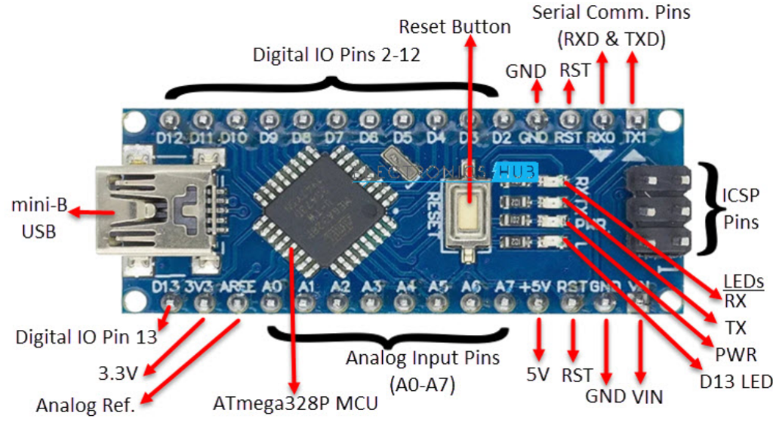  
Figure 3.7: Arduino Nano

# 3.5 Circuit Development

# This section shows clearly the development of the Electronic Mosquito Repellant Circuit from the initial to the final step.

# 3.6 The Circuit on the Bread Board

# Following critically the circuit diagram, the components of the circuit were connected and it's working tested as below.

# 3. 7 Circuit Operation

# The mosquito-repelling circuit operates by leveraging the Arduino microcontroller to generate ultrasonic frequencies that are converted into sound waves by a piezoelectric buzzer. This simple yet effective setup provides a non-toxic method to repel mosquitoes, utilizing the properties of ultrasonic sound to create an environment that is uncomfortable for these pests. The ease of programming and adjusting the Arduino allows for customization of the frequency and timing, making this approach adaptable to different situations and potentially more effective in various environments. Through careful design and operation, this circuit offers an innovative solution to reducing mosquito-borne health risks.

# The operation of the circuit can be divided into several steps:

# Initialization: When the circuit is powered on, the Arduino initializes its input and output settings. The pin connected to the buzzer (e.g., pin 8) is set as an output pin.

# Frequency Generation: The Arduino is programmed to generate a 20 kHz signal using the tone() function. This function creates a square wave of the specified frequency on the output pin. The square wave signal alternates between high and low states at a rate that corresponds to the desired frequency.

# Signal Transmission: The generated signal is sent to the piezoelectric buzzer. When the buzzer receives the signal, the piezoelectric element inside it vibrates rapidly, converting the electrical energy into ultrasonic sound waves. These sound waves are emitted into the surrounding environment.

# Timing Control: The program includes a timing mechanism to control the duration and interval of the ultrasonic sound. For instance, the buzzer might emit the 20 kHz sound for 30 seconds, followed by a 10-second pause. This intermittent operation can be more effective in disturbing mosquitoes, as it prevents them from becoming desensitized to the sound.

# Continuous Operation: The cycle of generating the ultrasonic frequency and pausing continues indefinitely as long as the circuit is powered. The Arduino’s loop function ensures that the sound emission pattern repeats continuously.

# CHAPTER FOUR

# RESULTS AND DISCUSSION

# 4.0 Introduction

# This chapter explains and shows the results obtained from the project. It indicates the objectives of the project that has been achieved and the overall performance of the circuit and the project as a whole.

# 4.1 Results

# After completing the construction of the circuit, it was tested and found out that it is functioning well as it follows the astable multivibrator principle of the analogue integrated circuit timer.

# The concept of the circuit is to generate continuous stream of rectangular pulse having a specified frequency range. At the output of the Electronic Mosquito Repellant circuit, a buzzer produces a high frequency sound which can be detected if it is within the audible range. If it is beyond the audible range, that is, above 20 KHz the sound cannot be heard by Humans and this sound is what triggers the auditory sense of the mosquitoes.

# The frequency of the sound produced can be varied by changing the value of the variable resistor R> in the circuit. The user can vary this resistor depending on the desired frequency of operation and the relationship is given by equation 3.1 above.

# In the circuit, the resistor R is a fixed resistor of resistance lkilo ohm, R2 is a variable resistor of resistance 2 kilo ohm and C is a ceramic capacitor of capacitance 0.01 microfarad. therefore, setting at 2 kilo ohm the buzzer is expected to produce a sound of (1000+(2x2000)) x 0.01x106 frequency calculated as F -= 28.8 kHz

# 

# Figure 4.0: Image of Prototype of Mosquito Repellant Design

# When the working of the circuit was tested and the frequency measured for the sound signal produced by the buzzer, the frequency also varied with the value of the resistor R2 as expected according to a stable frequency theory. The results were obtained by taking readings from the CRO as below.

# CRO Readings

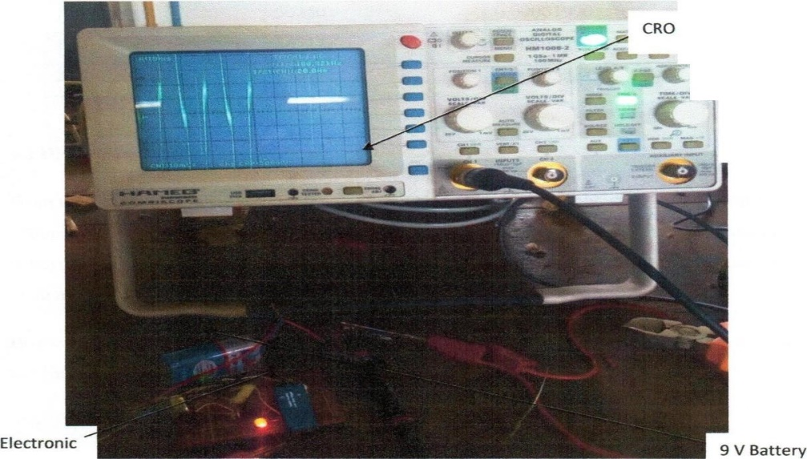

-

l

I

# Fig 4.1 CRO Readings

# the display will show a waveform corresponding to the nature of the signal (e.g., sine wave, square wave, triangular wave).

# A smooth, continuous wave with a consistent, periodic rise and fall was observed, the waveform was regular and a sinusoidal shape. the frequency of the waveform will be 20 kHz, meaning it completes 20,000 cycles per second. A series of rectangular pulses with abrupt transitions between high and low levels.

# Time Base Setting: To properly display a 20 kHz signal, you need to adjust the time base (horizontal scale) appropriately. For a 20 kHz signal, the period is

# 𝑇 = 1 𝑓 = 1 20000, T= f 1 = 20000 1 seconds, which is 50 microseconds (µs). Set the time base so that you can view multiple cycles clearly (e.g., 10 µs/div or 20 µs/div).

# CHAPTER FIVE

# CONCLUSIONS AND RECOMMENDATION

# 5.0 Introduction

# This is the last chapter that gives the conclusive remark on the entire project and it also spells out the recommendations for improvement of the project basing on the difficulties

# met during the whole project.

# 5.1 Conclusion

# Development of a mosquito repellant that is safe, effective and superior to chemicals in the protection of humans against mosquito is of great importance. Since Electronic Mosquito Repellant has nothing to do with chemicals, it is therefore safe and convenient with no health threat to humans. This is because it produces ultrasound, inaudible to humans and no effect but affect mosquitoes. Basing on the theory, the Microcontroller works as a stable multivibrator principle where in the circuit it acts as an oscillator used to generate clock pulses in a wide range of frequencies with enough output power. This output then drives the high frequency buzzer hence producing the sound.

# The frequency can be varied by using a potentiometer. The results obtained show that the circuit is able to generate an ultrasound ranging from the frequency of 29,670Hz to 101,220Hz according to the value of the resistor R; that is the potentiometer. According to the studies, mosquitoes are repelled by sound whose frequency ranges from 20 kHz to 40 kHz. This is because the sound produced by the flight of the male mosquito lies within this range which was the basis for the design of the circuit. Audible sound can also be generated and can repel mosquitoes but basing on a different principle. That is high frequency but audible sounds are known to induce stress on the antenna of the mosquitoes hence irritating and scaring them away. Since the sound is irritating, it is less likely that the mosquitoes will get used to the sound. If audible sound is being used, it is preferable that it is placed outside to avoid inconveniencing people who are inside.

# 5.2 Recommendations

# Therefore, the following need to be improved

# i) Placing a sensor that can detect the presence of mosquito and switches on the circuit automatically.

# ii) Use of direct current and battery cha2r0ger circuit so that the circuit can operate even

# during black out because usually mosquitoes are attracted to dark places.

# iii) Using microcontrollers and ultrasonic sensors to transmit the sound in a special band

# of frequency.

# iv) According to the results above, varying the resistance of the potentiometer brings about variation in the frequency of the sound produced. This implies that the device requires a lot of frequency setting in order to realize the desired frequency. I would propose the use of a fixed resistor so that the desired frequency can be realized without need for frequency setting.

# REFERENCES

# Chen, Y., et al. (2019). "Solar-Powered Mosquito Repellent System." Journal of Renewable Energy, 2019.

# Gupta, S., & Singh, R. (2023). "Challenges and Prospects in Electronic Mosquito Repellent Systems." Journal of Insect Science, 23(1), 45-57.

# Johnson, A., & Garcia, M. (2018). "Biological Approaches to Mosquito Repellency in Electronic Circuits." International Journal of Biological Control, 12(3), 112-125.

# Kim, S., et al. (2020). "Low-Energy Mosquito Repellent Circuit for Sustainable Operation." Journal of Sustainable Electronics, 8(2), 45-58.

# Li, H., et al. (2022). "Smart Mosquito Repellent Systems for Home Automation." IEEE Transactions on Smart Technologies, 13(4), 567-578.

# Lien, V. H. (2017). "Historical Perspectives on Mosquito Repellents." Journal of Vector Borne Diseases, 54(1), 73-79.

# Ong, S. Q., et al. (2020). "Comparative Study of Chemical and Electronic Mosquito Repellents." Journal of Environmental Health Science and Engineering, 18(2), 789-802.

# Patel, R., et al. (2021). "Ultrasonic Mosquito Repellent: An Experimental Study." Journal of Experimental Biology and Medicine, 10(4), 211-225.